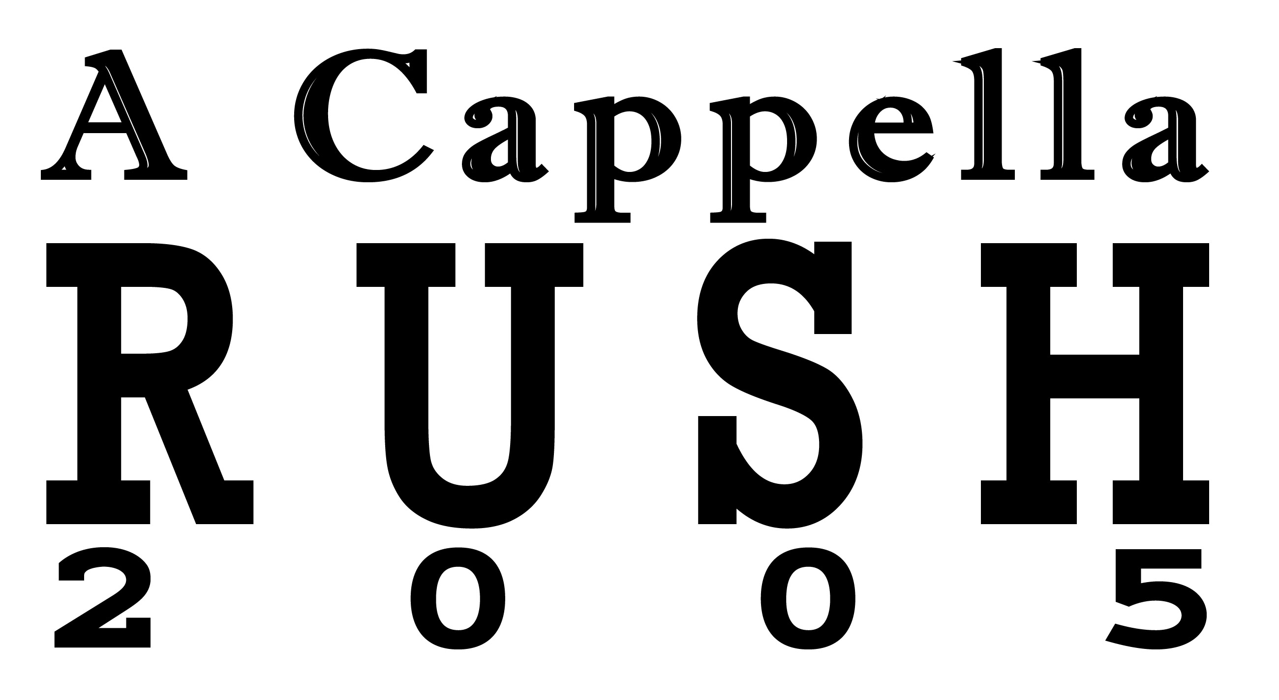

Michigan Union Ballroom
September 6, 8 pm

Come See a FREE Sampling of U of M’s
Finest A Cappella Groups



Sponsored by Michigan A Cappella Council

